Authorization for Release of Protected Health Information (PHI)
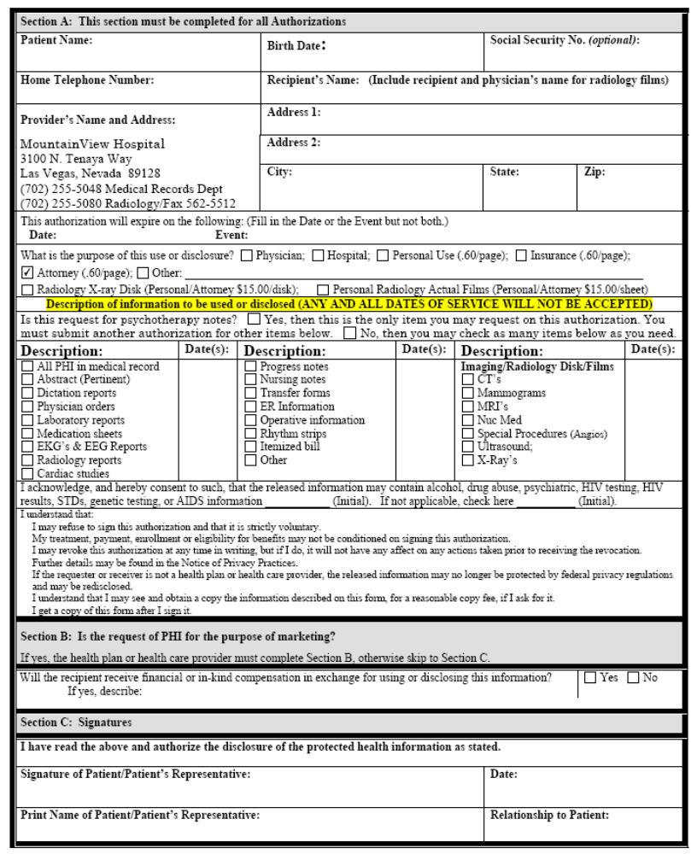
Order No. 01-18897 - 026
Cindy Beth Clardy
05/25/1950
XXX-XX-4649
447 North Canal Road
Lansing MI 48917
Axiom Requisition Copy Service as agent of Robert P.McArdle
X

